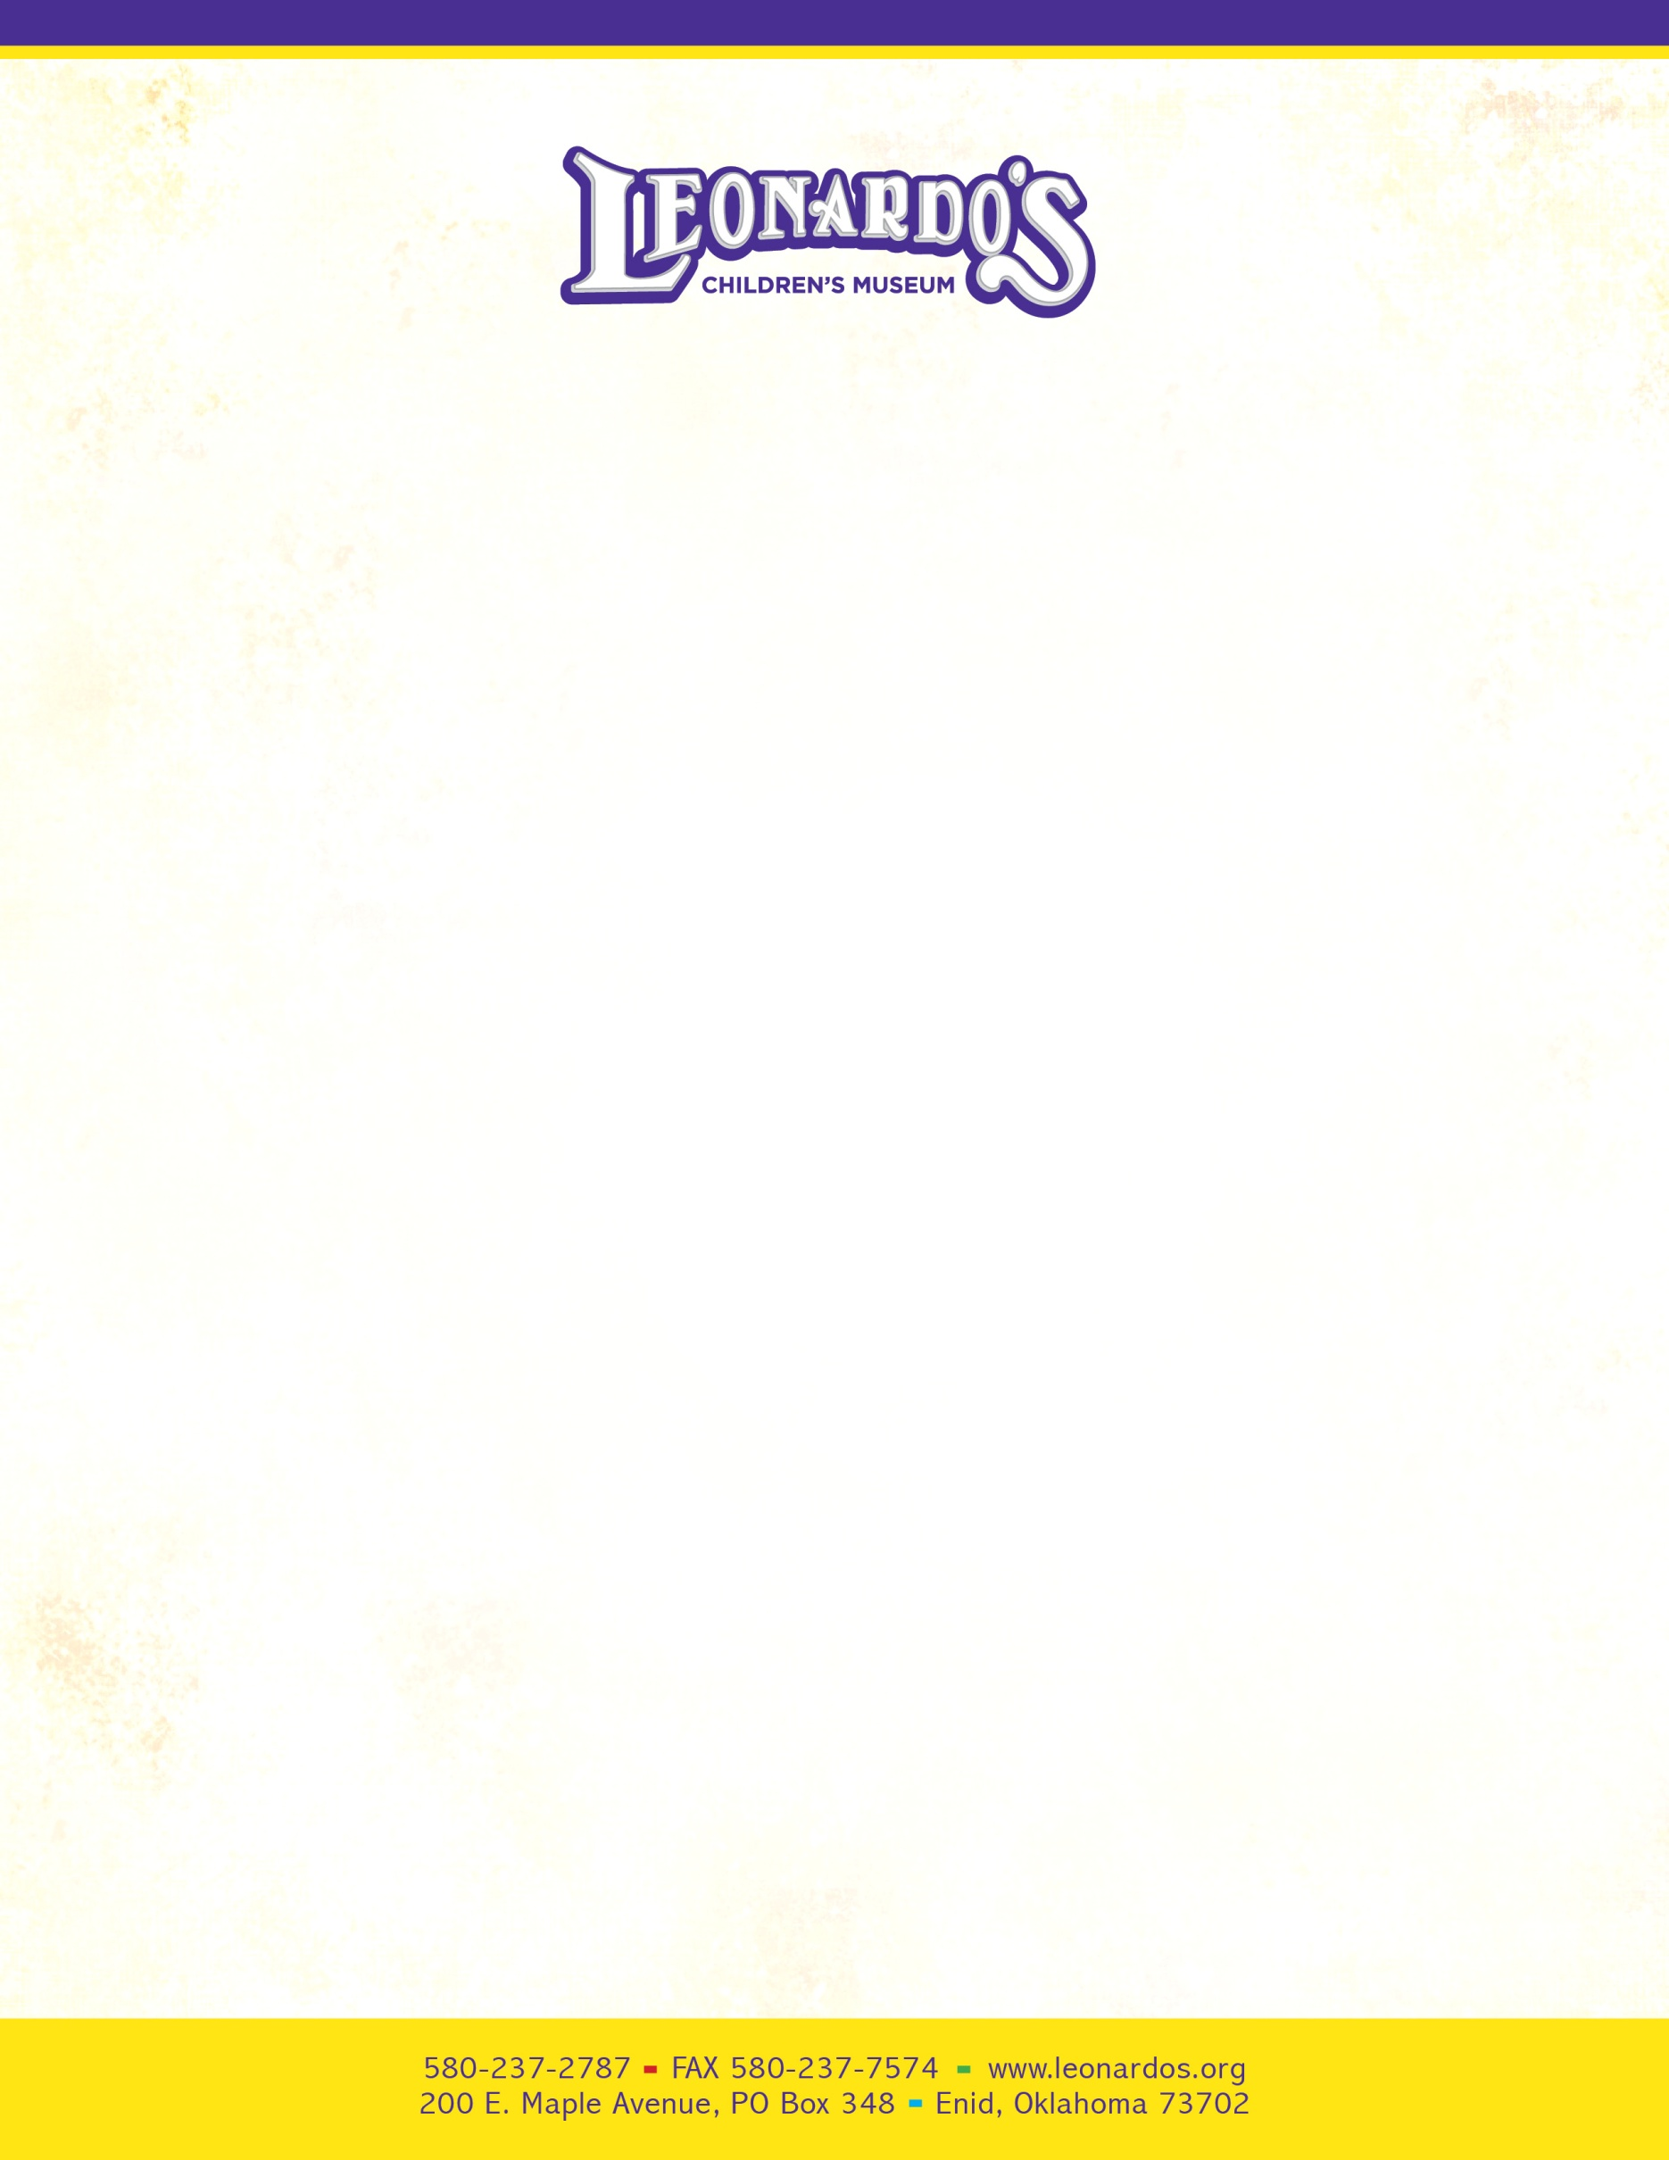

September 1, 2016

To: Enid Title 1 Elementary Schools

**Regarding: Perry & Goldie Davis Title 1 Scholarship Program**

Dear Principal or Classroom Teacher:

As you may have heard, a generous local benefactor has partnered with us to make sure that the students in your school have an opportunity to visit Leonardo’s Children’s Museum at least once per year. This grant is available on a *first-come, first-served basis* only for the first 2,500 guests to schedule per year with the following provisions:

* The visits take place on a Tuesday, Wednesday, or Thursday ONLY between October 1, 2016 and March 31, 2017. NO Exceptions!
* There **must** be **1 adult for every 5 students** attending, NO EXCEPTIONS. All students, teachers and parents will be admitted free, as well as younger siblings. Due to safety reasons, any school who does not have 1 adult for every 5 students will not be allowed into the museum. ***Please make sure your students understand that this is a privilege, and that they will be expected to respect our property and follow safety rules***.
* We will try to honor your requests for the number of students attending each day, but recommend that it be one or two grades close to each other, not to exceed 250 people each day.
* Each class will need to send a thank you note to the benefactor. You may have the teacher write one note and have all the students sign it, or you may have each student write their own thank you notes. They are to be addressed to: **Mr. Ray Davis c/o Leonardo’s**. You may mail the notes or drop them by the museum and we will make sure he gets them.

We are pleased to be able to make this special opportunity available to your school and students. Please call me to schedule at your earliest convenience.

Sincerely,

Julie P. Baird

Julie P. Baird, Executive Director